**CS5P1 : Visual Programming Lab**

**PART - A**

1. Write a VB Program to design a simple calculator to perform addition, subtraction, multiplication and division(Use functions for the calculations).
2. Design a User Interface (UI) to accept the student details such as name, department and total marks. Validate the input data and calculate the percentage and division.
3. Design a VB application which has MDI and Child forms. Create a menu having the items such as file (New, Open),Format (Font, Regular, Bold ,Italic) and Exit in the MDI form. Also create a text box and use a Common Dialog Box control for changing the font, fore color and back color of the text box.
4. VB program to Encrypt and Decrypt a string. (Use Rnd() to generate the Encryption and Decryption keys).
5. **5.Design a small Alarm Clock Application.**
6. Write a VB Program to Validate the username and password form the database and display the appropriate message.(Use Data Control)
7. Design a VB application to record the employee details such as EmpId, EmpName, Designation and BaiscPay. Calculate the DA, HRA, Deduction and Gross Salary.(Make the necessary assumptions )Use Select .. case for decision making.
8. VB program to calculate the simple interest and compound interest. Use DLLs for the calculation.

**Part – B**

1. **Write a VB program to find factorial of a given number.**
2. **write a VB program to create Airline reservation system.**
3. **Write a VB program to find given number is odd or even.**
4. **Write a VB program to change the back color of the text box using Scroll bars.**
5. **Write a VB program to change pictures in the Image box using Timer.**
6. **Write a VB program to print Fibonacci series.**
7. **Write a VB program to display the image using file list box, directory and drive.**
8. **Write a VB program to find sum of N numbers.**

**CS5P1 : Visual Programming Lab**

**PART - A**

1)Write a VB Program to design a simple calculator to perform addition, subtraction, multiplication and division(Use functions for the calculations).

Dim a As Double, b As Double

Dim op As String

Private Sub Command1_Click(Index As Integer)

Text1.Text = Text1.Text + Command1(Index).Caption

End Sub

Private Sub Command2_Click(Index As Integer)

A = Val(Text1.Text)

Text1.Text = ""

If Command2(Index).Caption = "+" Then

op = "+"

ElseIf Command2(Index).Caption = "-" Then

op = "-"

ElseIf Command2(Index).Caption = "*" Then

op = "*"

ElseIf Command2(Index).Caption = "/" Then

op = "/"

End If

End Sub

Private Sub Command3_Click()

b = Val(Text1.Text)

If op = "+" Then

Text1.Text = a + b

ElseIf op = "-" Then

Text1.Text = a - b

ElseIf op = "*" Then

Text1.Text = a * b

ElseIf op = "/" Then

Text1.Text = a / b

End If

End Sub

Private Sub Command4_Click()

Text1.Text = ""

End Sub

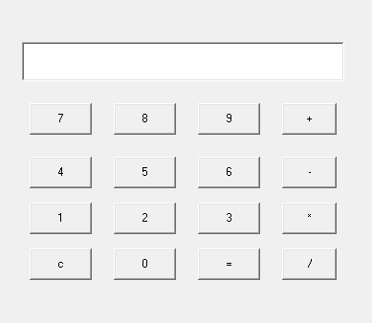

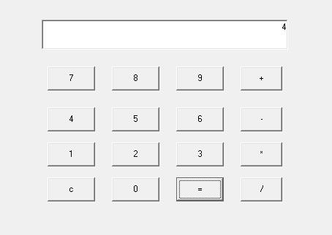

2)Design a User Interface (UI) to accept the student details such as name, department and total marks. Validate the input data and calculate the percentage and division.

STUDENT MARKS

Private Sub Command1_Click()

Dim a As Integer

Text6.Text = Val(Text3.Text) + Val(Text4.Text) + Val(Text5.Text)

Text7.Text = Val(Text6.Text) / 3

a = Val(Text7.Text)

If a > 75 Then

Text8.Text = "Distinction"

ElseIf a > 60 Then

Text8.Text = "First Class"

ElseIf a > 50 Then

Text8.Text = "Second class"

ElseIf a > 40 Then

Text8.Text = "Pass class"

Else

Text8.Text = "Fail"

End If

If Val(Text3.Text) < 35 Then

Text8.Text = "Fail"

End If

If Val(Text4.Text) < 35 Then

Text8.Text = "Fail"

End If

If Val(Text5.Text) < 35 Then

Text8.Text = "Fail"

End If

End Sub

Private Sub Text3_KeyPress(KeyAscii As Integer)

If KeyAscii < 48 Or KeyAscii > 57 Then

KeyAscii = 0

MsgBox "Enter number only"

End If

End Sub

Private Sub Text4_KeyPress(KeyAscii As Integer)

If KeyAscii < 48 Or KeyAscii > 57 Then

KeyAscii = 0

MsgBox "Enter number only"

End If

End Sub

Private Sub Text5_KeyPress(KeyAscii As Integer)

If KeyAscii < 48 Or KeyAscii > 57 Then

KeyAscii = 0

MsgBox "Enter number only"

End If

End Sub

Private Sub Command2_Click()

End

End Sub

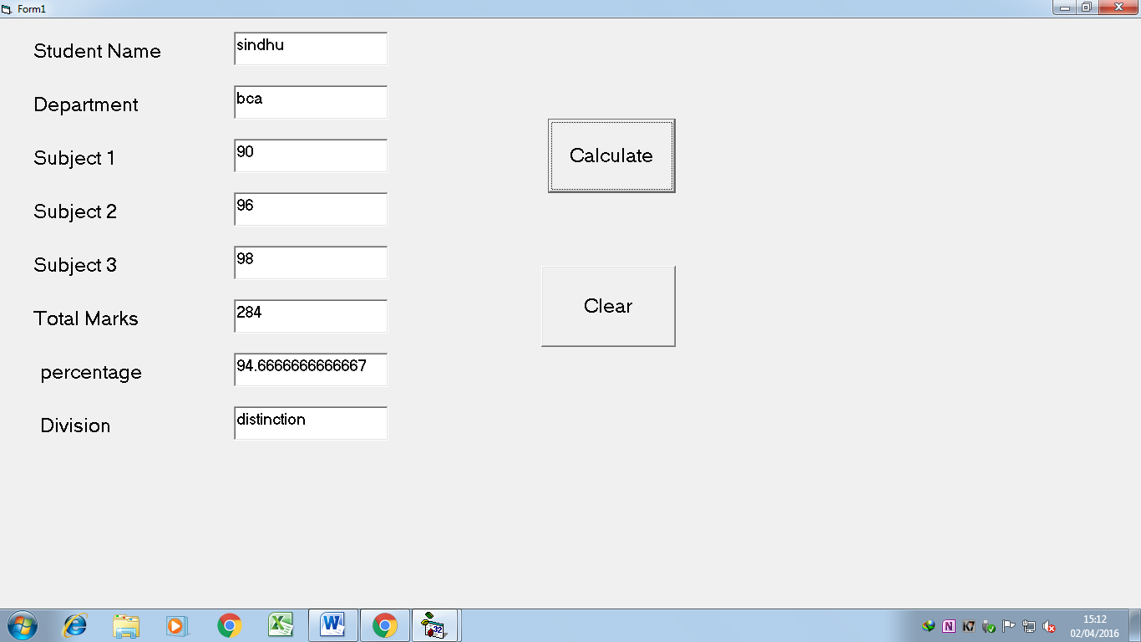

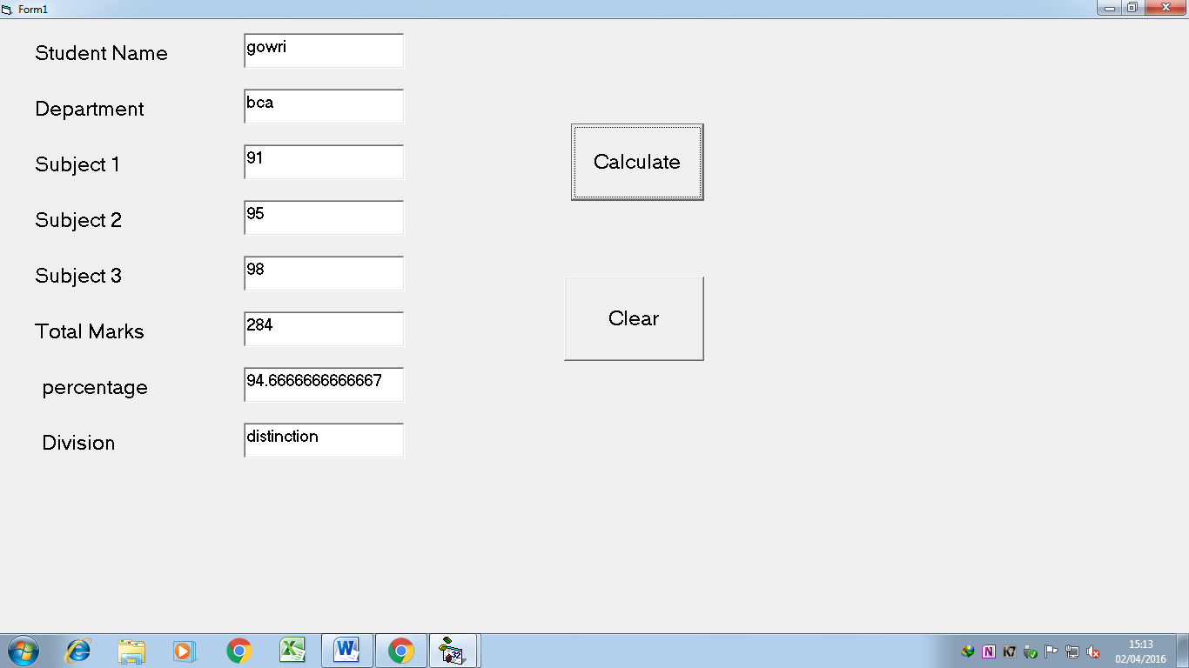

3)Design a VB application which has MDI and Child forms. Create a menu having the items such as file (New, Open),Format (Font, Regular, Bold ,Italic) and Exit in the MDI form. Also create a text box and use a Common Dialog Box control for changing the font, fore color and back color of the text box.

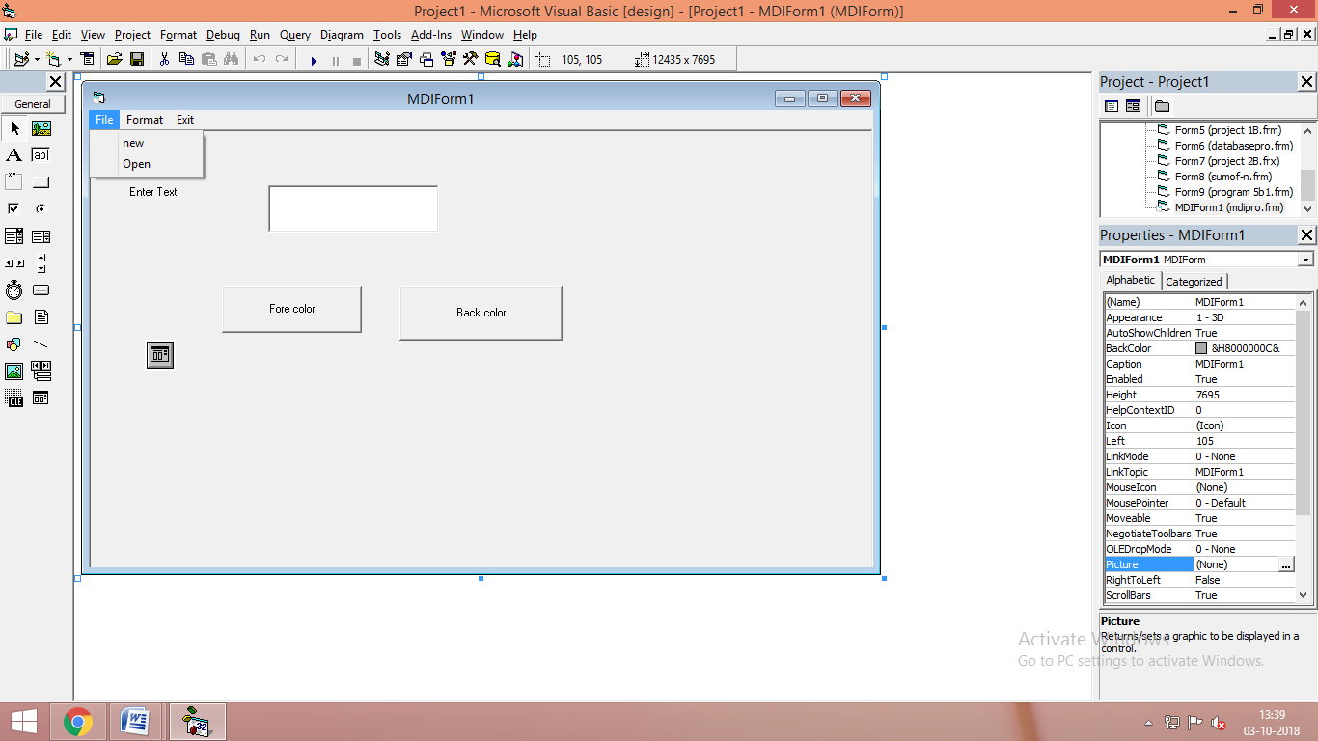

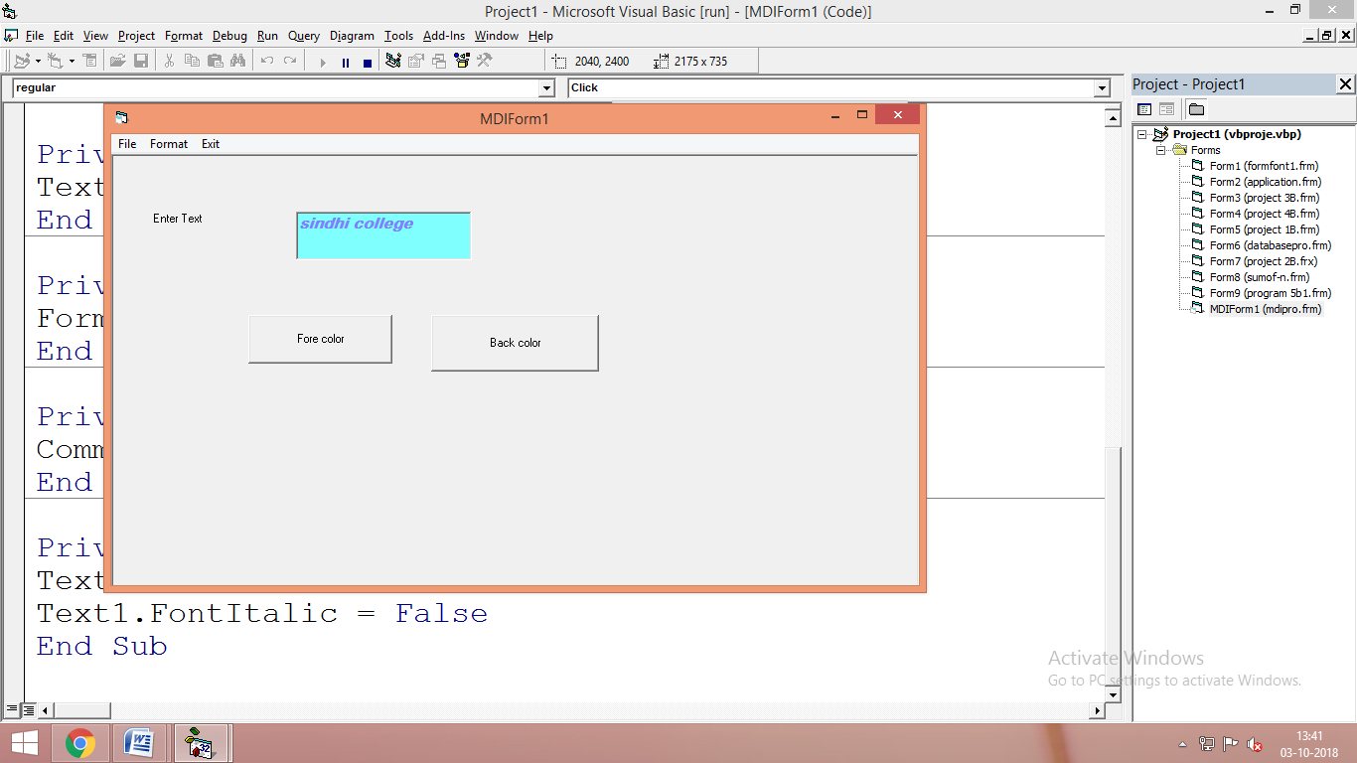

Private Sub Command1_Click() Private Sub regular_Click()

CommonDialog1.ShowColor Text1.FontBold = False

Text1.ForeColor = CommonDialog1.Color Text1.FontItalic = False

End Sub End Sub

Private Sub Command2_Click()

CommonDialog1.ShowColor

Text1.BackColor = CommonDialog1.Color

End Sub

Private Sub font_Click()

CommonDialog1.ShowFont

Text1.FontName = CommonDialog1.FontName

Text1.FontSize = CommonDialog1.FontSize

End Sub

Private Sub italic_Click()

Text1.FontItalic = True

End Sub

Private Sub new_Click()

Form1.Show

End Sub

Private Sub open_Click()

CommonDialog1.ShowOpen

End Sub

4)VB program to Encrypt and Decrypt a string. (Use Rnd() to generate the Encryption and Decryption keys).

**Public Function RndCrypt(ByVal str As String) As String**

Dim K As Long

' init randomizer for encryption/decryption

Rnd -1

' encrypt/decrypt every character using the randomizer

For K = 1 To Len(str)

Mid$(str, K, 1) = Chr(Fix(256 * Rnd) Xor Asc(Mid$(str, K, 1)))

Next K

RndCrypt = str

**End Function**

**Private Sub Command1_Click()**

If Command1.Caption = "Encrypt" Then

Text1.Text = RndCrypt(Text1.Text)

Label1.Caption = "Encrypt Text"

Command1.Caption = "Decrypt"

ElseIf Command1.Caption = "Decrypt" Then

Text1.Text = RndCrypt(Text1.Text)

Label1.Caption = "Decrypt Text"

Command1.Caption = "Encrypt"

End If

**End Sub**

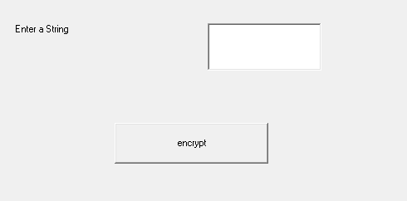

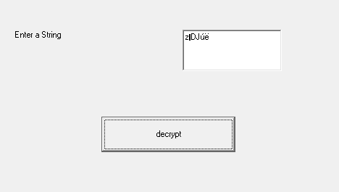

**5.Design a small Alarm Clock Application.**

Private Sub Command1_Click()

Timer1.Enabled = True

End Sub

Private Sub Timer1_Timer()

Label2.Caption = Time

If Val(Text1.Text) = Hour(Label2.Caption) And Val(Text2.Text) = Minute(Label2.Caption) Then

Print " Alarm On"

Else

Exit Sub

End If

End Sub

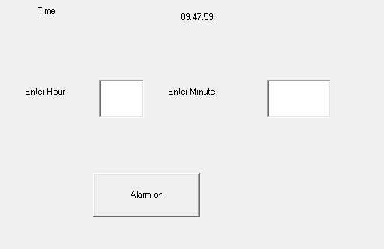

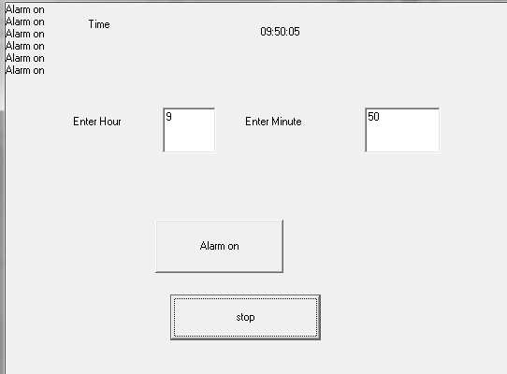

1. Write a VB Program to Validate the username and password form the database and display the appropriate message.(Use Data Control)

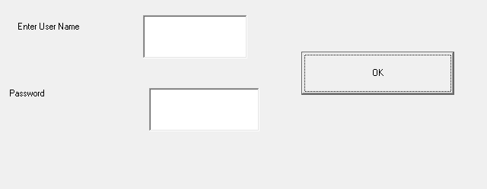

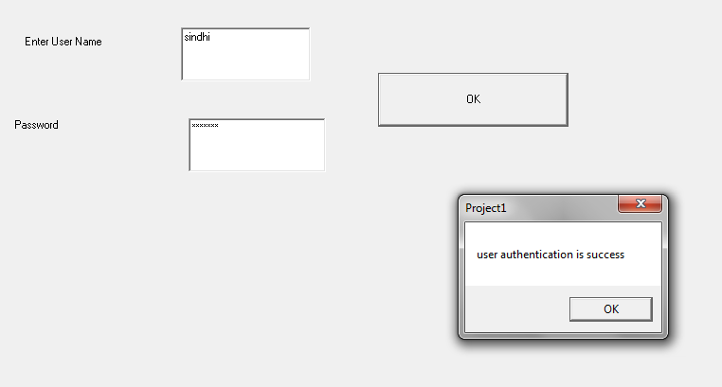

Private Sub Command1_Click()

If Data1.Recordset.EOF Then

Data1.Recordset.MoveFirst

End If

If Text1.Text = Data1.Recordset.Fields(0).Value Then

If Text2.Text = Data1.Recordset.Fields(1).Value Then

MsgBox "User authentication is success”

Else

MsgBox "Password is wrong"

End If

Else

MsgBox "User name is wrong"

End If

End Sub

7. Design a VB application to record the employee details such as EmpId, EmpName, Designation and BaiscPay. Calculate the DA, HRA, Deduction and Gross Salary.(Make the necessary assumptions )Use Select .. case for decision making.

Dim da As Double, hra As Double, pf As Double, gr As Double, bs As Double

Private Sub Command1_Click()

bs = Val(Text4.Text)

Select Case bs

Case Is >= 50000

da = bs * 20 / 100

hra = bs * 10 / 100

pf = bs * 12 / 100

Case Is >= 25000

da = bs * 15 / 100

hra = bs * 8 / 100

pf = bs * 10 / 100

Case Else

da = bs * 10 / 100

hra = bs * 5 / 100

pf = bs * 8 / 100

End Select

Text5.Text = da

Text6.Text = hra

Text7.Text = pf

Text8.Text = bs + da + hra - pf

End Sub

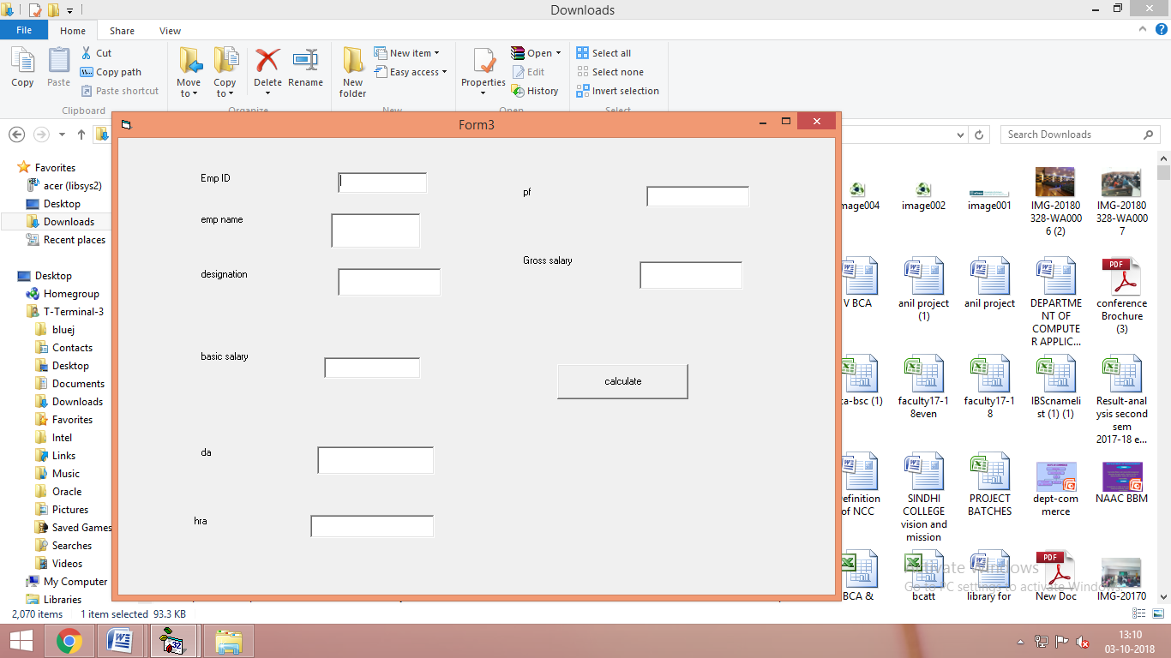

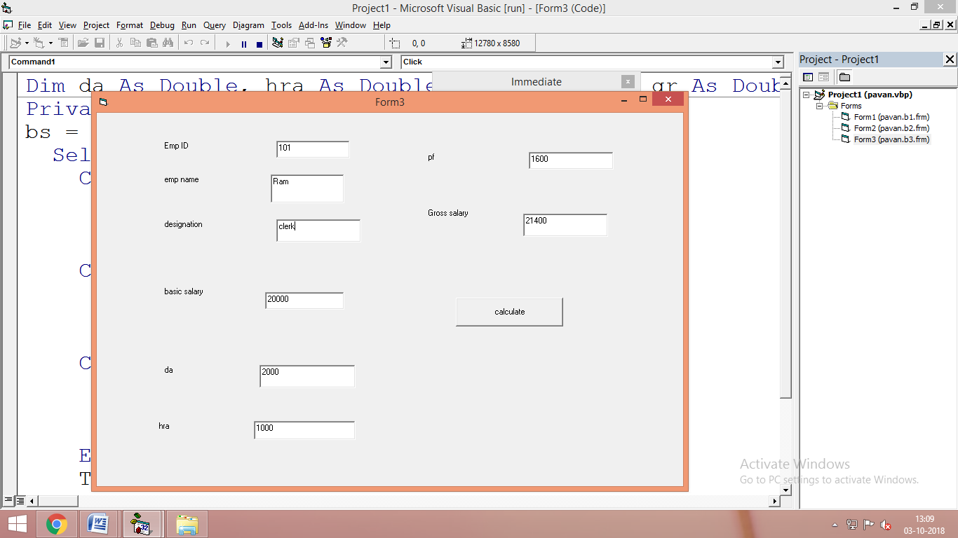\

1. VB program to calculate the simple interest and compound interest. Use DLLs for the calculation.

Main Program

Dim obj As New Class1

Dim p As Double, t As Double, r As Double

Dim si As Double, ci As Double

Private Sub Form_Load()

Set obj = New Class1

End Sub

Private Sub Command1_Click()

p = Val(Text1.Text)

t = Val(Text2.Text)

r = Val(Text3.Text)

si = obj.simpleint(p, t, r)

Text4.Text = si

End Sub

Private Sub Command2_Click()

p = Val(Text1.Text)

t = Val(Text2.Text)

r = Val(Text3.Text)

ci = obj.compoundint(p, t, r)

Text5.Text = ci

End Sub

Class module

Dim si As Double, ci As Double

Public Function simpleint(a As Double, b As Double, c As Double)

simpleint = a * b * (c / 100)

End Function

Public Function compoundint(a As Double, b As Double, c As Double)

Dim d As Double

d = a * (1 + c / 100) ^ b

compoundint = d - a

End Function

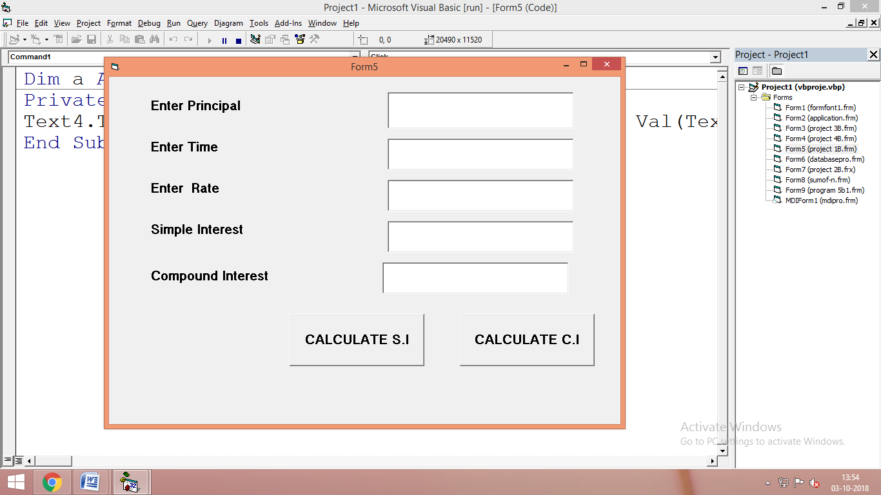

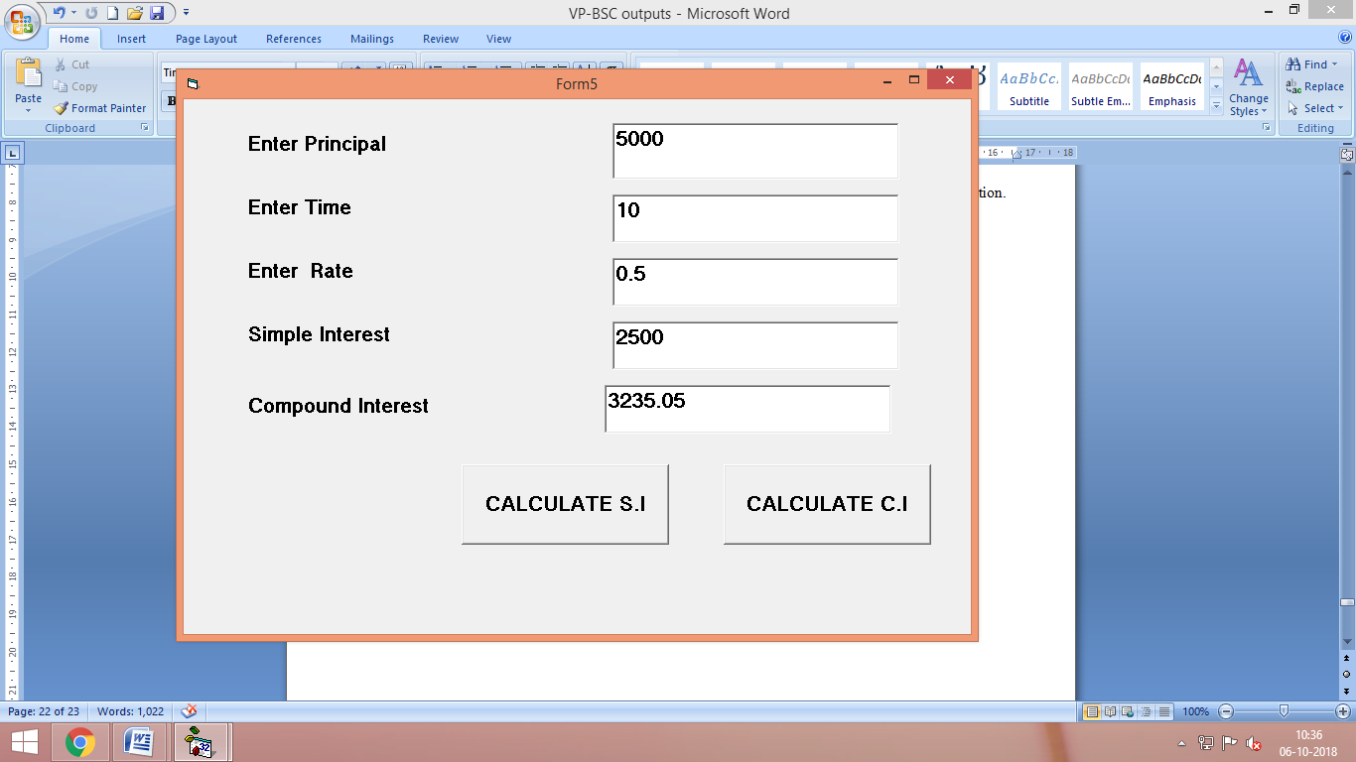

**Part – B**

1. **Write a VB program to find factorial of a given number.**

**Private Sub Command1_Click()**

**Dim n As Integer, i As Integer**

**Dim f As Double**

**f = 1**

**n = Val(Text1.Text)**

**For i = 1 To n**

**f = f * i**

**Next i**

**Text2.Text = f**

**End Sub**

FACTORIAL

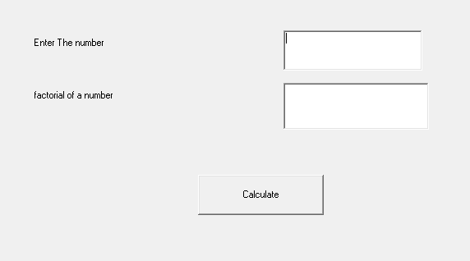

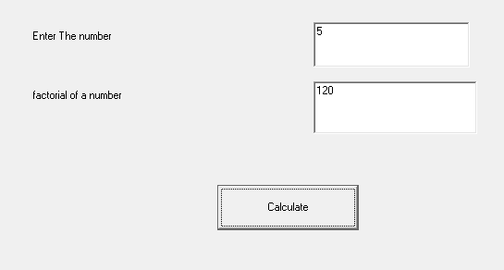

1. **Write a VB program to create Airline reservation system.**

**Private Sub Command1_Click()**

**If Option1.Value = True Then**

**Text3.Text = Val(Text1.Text) * Val(Text2.Text)**

**MsgBox "Your ticket is confirmed with Rs." + Text3.Text, 1, "Ticket"**

**ElseIf Option2.Value = True Then**

**Text3.Text = Val(Text1.Text) * Val(Text2.Text)**

**MsgBox "Your ticket is confirmed with Rs." + Text3.Text, 1, "Ticket"**

**ElseIf Option3.Value = True Then**

**Text3.Text = Val(Text1.Text) * Val(Text2.Text)**

**MsgBox "Your ticket is confirmed with Rs." + Text3.Text, 1, "Ticket"**

**ElseIf Option4.Value = True Then**

**Text3.Text = Val(Text1.Text) * Val(Text2.Text)**

**MsgBox "Your ticket is confirmed with Rs." + Text3.Text, 1, "Ticket"**

**End If**

**End Sub**

**Private Sub Option1_Click()**

**Text1.Text = 700**

**End Sub**

**Private Sub Option2_Click()**

**Text1.Text = 750**

**End Sub**

**Private Sub Option3_Click()**

**Text1.Text = 650**

**End Sub**

**Private Sub Option4_Click()**

**Text1.Text = 500**

**End Sub**

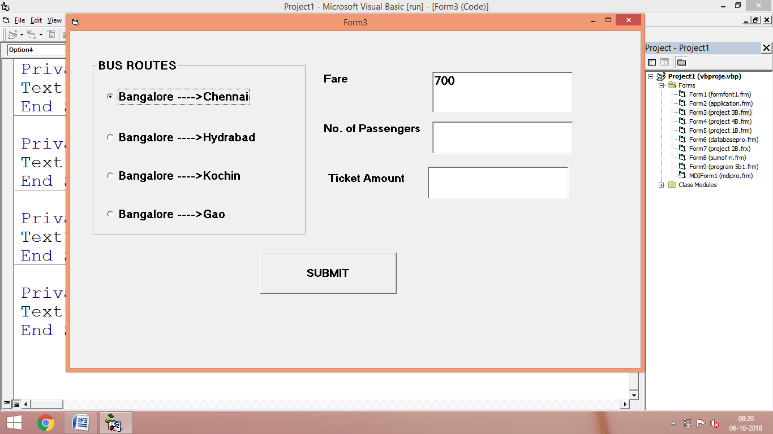

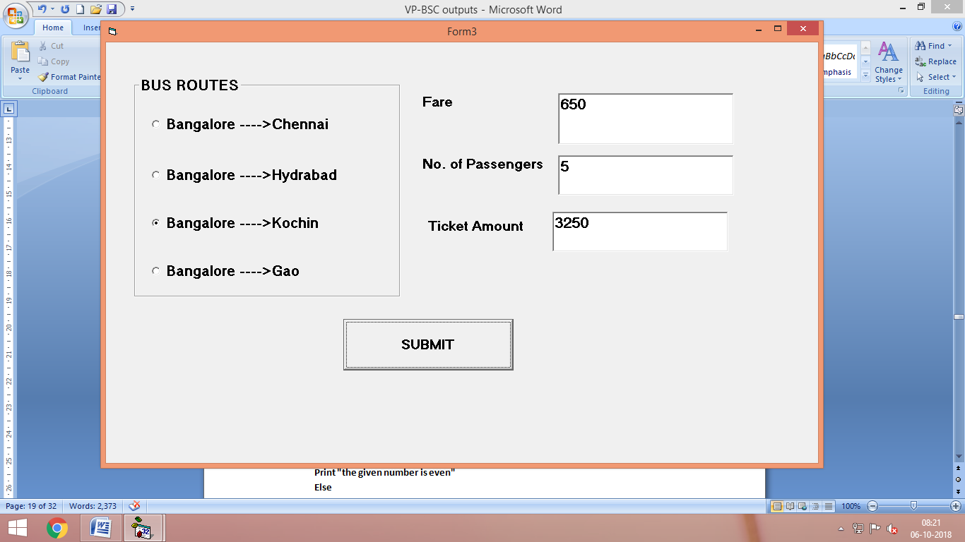

1. **Write a VB program to find given number is odd or even.**

**Private Sub Command1_Click()**

**If Val(Text1.Text) Mod 2 = 0 Then**

**Print "the given number is even"**

**Else**

**Print "the given number is odd"**

**End If**

**End Sub**

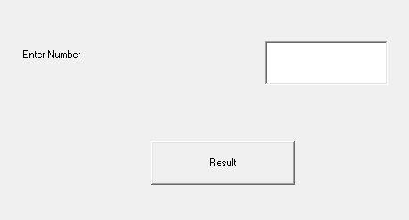

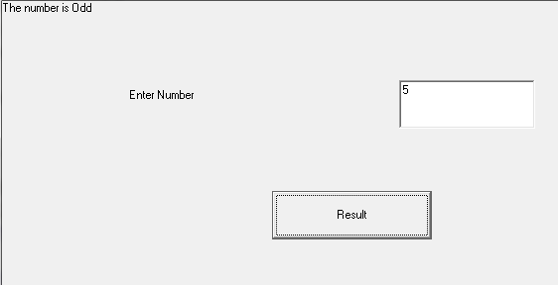

1. **Write a VB program to change the backcolor of the text box using Scroll bars.**

Private Sub HScroll1_Change()

Text1.BackColor = RGB(HScroll1.Value, HScroll2.Value, HScroll3.Value)

End Sub

Private Sub HScroll2_Change()

Text1.BackColor = RGB(HScroll1.Value, HScroll2.Value, HScroll3.Value)

End Sub

Private Sub HScroll3_Change()

Text1.BackColor = RGB(HScroll1.Value, HScroll2.Value, HScroll3.Value)

End Sub

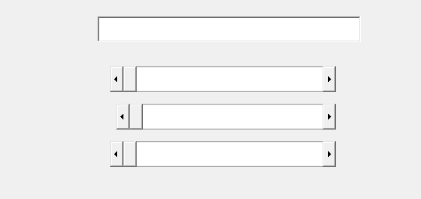

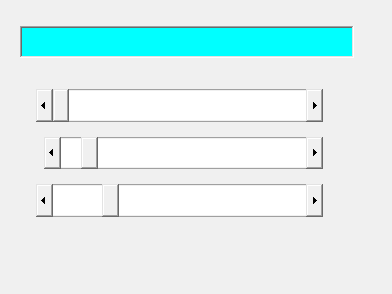

1. **Write a VB program to change pictures in the Image box using Timer.**

Dim a As Integer

Private Sub Command1_Click()

Timer1.Enabled = True

End Sub

Private Sub Command2_Click()

Timer1.Enabled = False

End

End Sub

Private Sub Form_Load()

a = 0

End Sub

Private Sub Timer1_Timer()

If a < 3 Then

Image2.Picture = Image1(a).Picture

a = a + 1

ElseIf a > 2 Then

a = 0

End If

End Sub

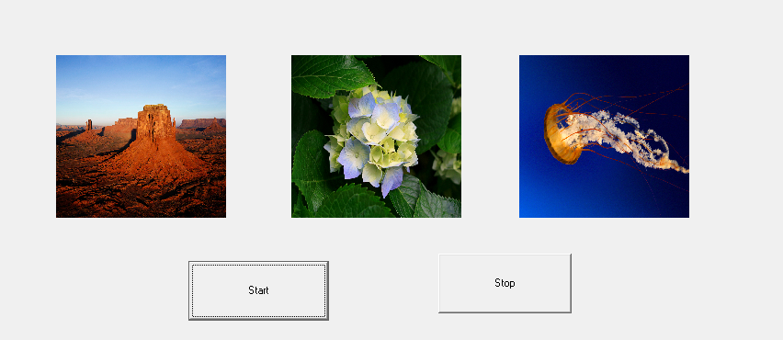

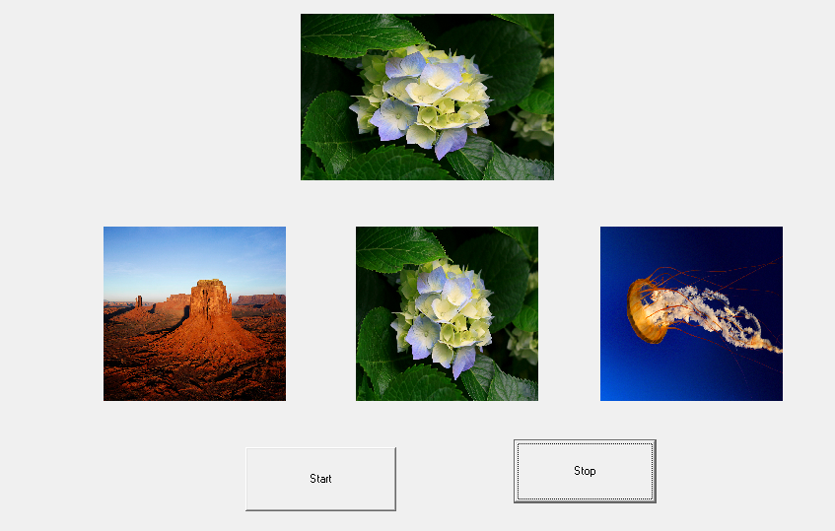

1. **Write a VB program to print Fibonacci series.**

Private Sub Command1_Click()

Dim f1 As Integer, f2 As Integer, f3 As Integer

Dim i As Integer

f1 = 0

f2 = 1

Print "fibonacci series.."

Print f1

Print f2

For i = 3 To Val(Text1.Text)

f3 = f1 + f2

Print f3

f1 = f2

f2 = f3

Next i

End Sub

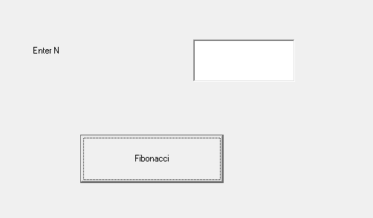

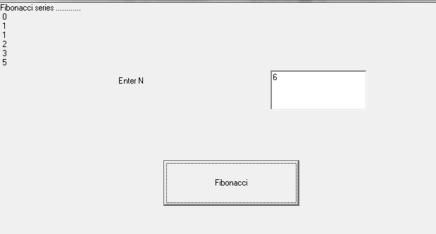

1. **Write a VB program to display the image using file listbox, directory and drive.**

**Private Sub Dir1_Change()**

**File1.Path = Dir1.Path**

**End Sub**

**Private Sub Drive1_Change()**

**Dir1.Path = Drive1.Drive**

**End Sub**

**Private Sub File1_Click()**

**Dim a As String**

**a = Dir1.Path & "\" & File1.FileName**

**Image1.Picture = LoadPicture(a)**

**End Sub**

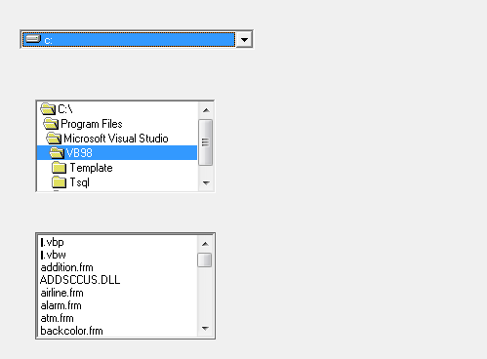

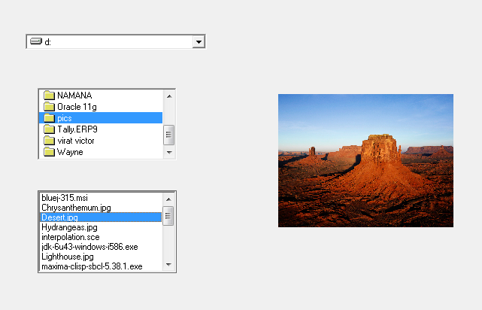

1. **Write a VB program to find sum of N numbers.**

**Private Sub Command1_Click()**

**Dim s As Integer, i As Integer**

**s = 0**

**For i = 1 To Val(Text1.Text)**

**s = i + s**

**Next i**

**Text2.Text = s**

**End Sub**

